Online shopping portal
[www.shoppingkart.com]

Business requirements document

Document information and approvals
Utors

Version history
Version # | Date |  | Revised by | Reason for change
1.0 | 4/04/2018 |  | Akhilesh panchagade | Review

This document has been approved as the official business requirements document for <www.shoppingkart.com>, and accurately reflects the current understanding of business requirements. Following approval of this document, requirement changes will be governed by the project’s change management process, including impact analysis, appropriate reviews and approvals.

Document approvals
Approver name | Project role |  | Signature/electronic approval | Date

Table of contents
1. Introduction 1
1.1 purpose 1
1.2 scope 1
1.3 definitions, acronyms and abbreviations 2
1.4 references 3
1.5 technologies to be used 3
1.6 overview 3
2. Overall descriptions 4
2.1 product perspective
2.2 product functions 5
2.3 user characteristics 6
2.4 constraints 6
2.5 use case model survey 7
2.5.1 use case diagram for customer 8
2.5.2 use case diagram for visitor 9
2.5.3 use case diagram for account manager 9
2.5.4 use case diagram for sales manager 9
2.5.5 use case diagram for customer care 10
2.8 use case diagram for administrator 10
2.6 sequence diagram 13
2.7 database design 14
2.9 sign and registration page 16
2.10 registration page 16
Conclusion 17

1. Document purpose
1.1 purpose
The online shopping web application is intended to provide complete solutions for vendors as well as customers through gate way using the internet as the sole medium. It will enable vendors to do online shopping, customer to browse through the shop and purchase them online without having to visit the shop physically. The administration module will enable the system administrator to approve and reject the requests for unreached shopping details.

This document is to delineate the features of online shopping, so as to serve as a guide to the developers
On one hand and software validation document for the prospective client on the other.

1.2 scope
Initial functional requirements would be:-
- Secure registrations and profile management facilities for customers.

- For example, browsing through the www.Shoppingkart.com to see the items that are there in each category of products like electronics, lifestyle accessories , etc.

- Adequate searching mechanisms for easy and quick access to particular products and services.

- Options to manage and refill prescriptions.

- Creating shopping cart so the customers can shop ‘n’ no. of items and checkout finally with the entire shopping carts.

- Regular candidates to registered customers of the company about new arrivals.

- Uploading the recent discount, weekly deals on all products online coupons.

- Strategic data and graphs for administrators and shop owners about the items that are popular in each category and age group.

- Maintaining database of regular customers of different needs.

- Shop employees are responsible for internal affairs processing orders, assure home delivery getting customer’s delivery time feedback, updatng order’s status and answering client’s queries online.

- Feedback mechanism, so that customers can give feedback for the product or service whicj they have purchased. Also facilty of individual products by relevant customers. Also feedback can be given on the performances of particular vendors and the entire mall as well.

- Adequate payment mechanism and gateway for all popular credit cards,cheques and other relevant payment options, as availiable from time to time.

For pervious paragraph, depicting the functions of the system from the perspective of the various users of the system ,the following colour coder can be used.
- Green for administrator.

- Blue for customer of the shopping mall.

- Red for the employees.

Initial non functional requirements will be:-

- Secure access of confedential data (user’s details). Ssl can be used.

- 24x 7 availability

- Better component design to get bette performance at a peak time.

- Advertisement space where it will effectively catch the customer’s attention and as a source of revenue.

In addition to the above mention points, due to the highly evolving nature of the project, the following are planned to be delivered if deemed necessary;

- Warehousing within the very ambits of the project.

- More payment gateways.

- Dynamic price model by which prices can be changed based on demand and supply.

- Dynamic storefront: each customer will have a web page personalized based on his or her recent purchases. This is the equivalent of having a unique storefront for each customer in hopes of drawing in as many return customers as possible.

This list is by no means, a final one. The final list will be dictated by implementation constraints market forces and most importantly, by end user demands for whom this is being built.

1.3 definitions, acronyms and abbreviations

- Sla: service level agreement or sla is a formal written agreement made between two parties, the service provider and the service receipetent. It defines the term of engagement – the fundamental rules that will administer the relationship.

- Http: hypertext transfer protocol is a transaction oriented client/server protocol between a web browser and a web server.

- Java ee: java enterprise edition 5 is a programming platform-- part of the java platform- for developing and running distributed multi-tier architecture java applications, based largely on modular software components running on an application server.

- Tcp/ip: transmission control protocol/internet protocol, the suite of communication protocols used to connect hostson the internet. Tcp/ip uses several protocols, the two main one’s being tcp and ip.

- Https: secure hypertext transfer protocol is a http over ssl( secure socket layer).
1.4 references

Ieee srs format

1.5 technologies to be used

Programming languages:

- Java ee: java enterprise edition is a programming platform-- part of the java platform- for developing and running distributed multi—tier architecture java applications, based largely on modular software component running on an application server.

- Html, xml: hyper text markup language for web pages. If provides a means to describe the structure of text-based information in a document and to supplement that text with interactive forms, embedded images, and other objects.

- Javascript: a client side scripting language used to create dynamic web content and user interface.

Tools and development environment:

- Apache tomcat 6.0.18 server: apache tomcat is a servlet container developed by apache software foundation (asf). It implements java saevlet and java servlet pages(jsp).

- Eclipse j2ee: eclipse is a tool kit which is designed for the creation of complex projects, providing fully dynamic web application utilizing ejb’s .this consist of ejb tools, universal test client and data mapping tools.
1.6 overview
The rest of this srs document is organized as follows: section 2 gives an overall description of the software. It gives what level of proficiency is expected of the user, some general constraints while making the software and some assumptions and dependencies that are assumed. Section 3 gives specific requirement switch the software is expected to deliver. Functional requirements are given by use cases. Some performances requirements and design constraints are also given.

2. Overall description

2.1 product perspective
Company online shopping is aimed towards conman people who can be potential customer. This projects connects the gap between the seller, the retailer and the customer. This online shopping must be user friendly, easy to learn and reliable. Software for the above purpose. Online shopping is intended to be a stand alone product and should not depend on the availability of other software. It should run on both windows and unix.

Stakeholders
The following comprises the internal and external stakeholders whose requirements are represented by this document:

 | Stakeholders
1. | Client, business analyst
2. | Users
3. | Development team

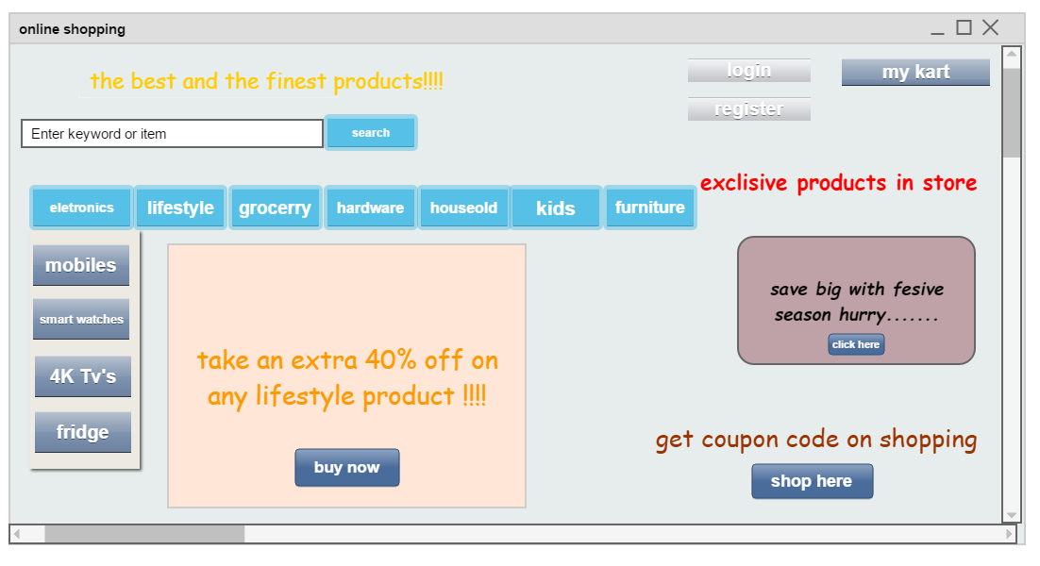

2.2 product functions

User: company administrator

Functions: the administrator is the super user and has complete control over all the activities that can be performed. The application notifies the administrator of all shop administrator of all shop inclusion requests, after that administrator can approve or reject them. The administrator can also manage the list of available product categories. The administrator can also view and delete entries in the guestbook.

2.3 user characteristics
- The user should be familiar with the online shopping related technology related terminology like shopping cart, transaction etc.

- The user should be familiar with the internet.

2.4 constraints

- There is no maintainability of back up so availability will get effected.

- Limited to https or http.

- Real life credit card validation and banking system is not implemented.

- No multilingual support.

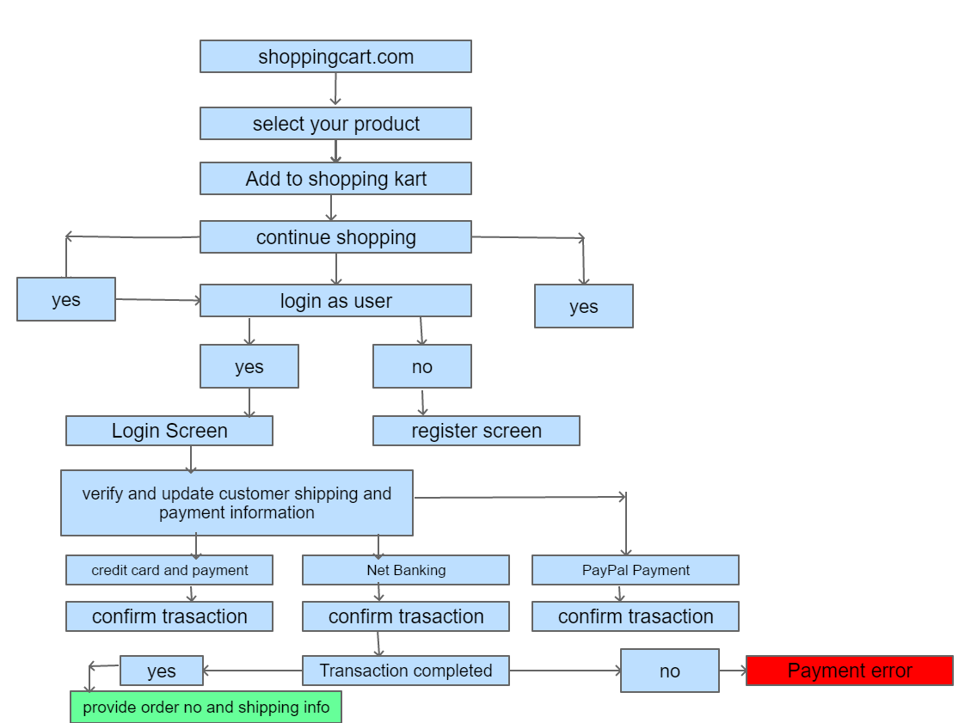
2.5 flow chart

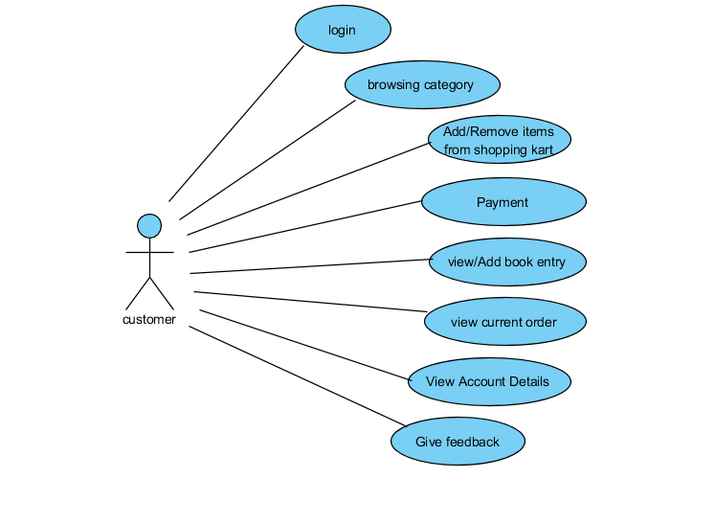

Figure: use case diagram for customer.

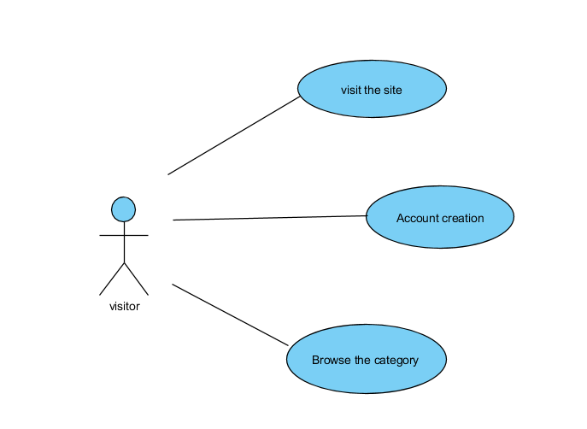

Figure: use case diagram for visitor.

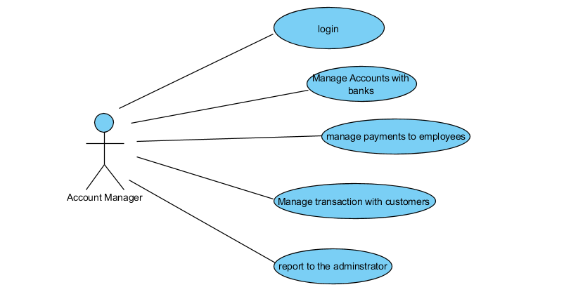

Figure: use case diagram for account manager.

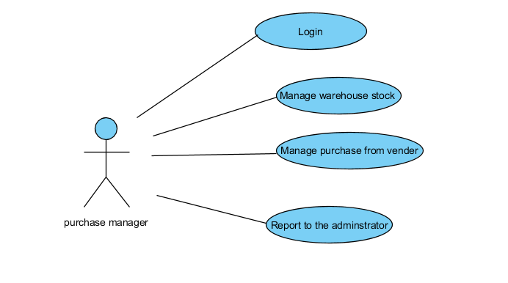

Figure: use case diagram for purchase manager.

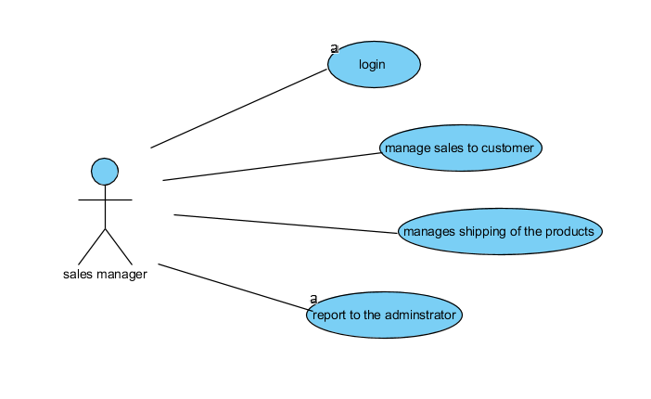

Figure: use case diagram for sales manager.

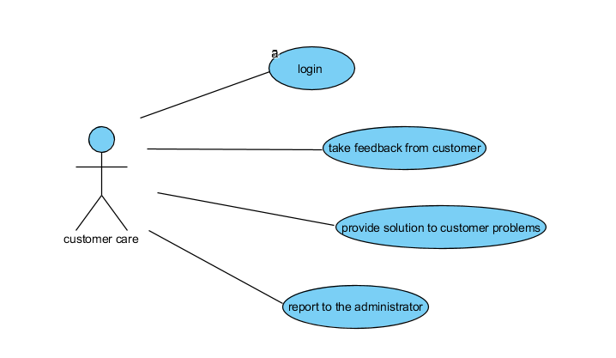

Figure: use case diagram for customer care.

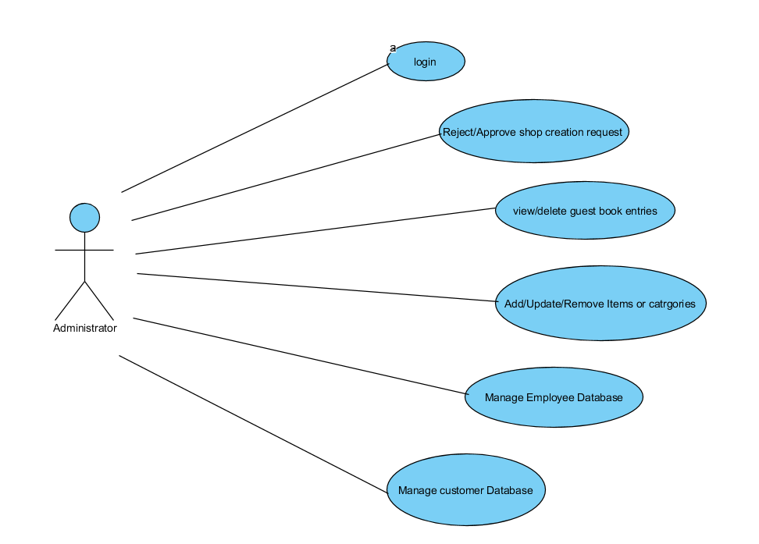

Figure: use case diagram for administrator.

Given below is overall picture of the system, as shown in all the above use case diagrams.

1. Admimstrator:

- Database management: control the database and keep track of all records of customers and employee details.

- Contact and giving permissions to vendors: contact with company vendors of particular location and give permission to sell their products under the site after testing the product’s quality.

- View all details: view all details of employee and and to control the full site.

- Advertising the site: responsible for making advertisement for the site.

2. Customers:

- Login: customers must esquire a valid login id to enter into the site.

- View and edit details: can view the personal details , payment details and details about the services provided.

- Registration: new users can sign up by creating new id.

- Purchasing: can purchase any product through valid payment option.

- Choosing and comparing own products: can view all available products and compare all the products to make a chaoice foe purchase products.

- Giving feedback to customer care: can give feedback to 24x7 available customer care services abut the impression of the bought products.

- Logout: customer must logout of the session from the site after purchasing the product.
3. Visitors:

- Visiting the site: visitors can vivst the sit without any registration process.

4. Sales manager:

- View customers details: view the personal detail of the customer.

- View product stocks: keep track of each product item’s stocks for selling purpose.
- Managing sales to customer: responsible for properly allocating the item selected according to the customer’s choice and delivering the item to the customer.

- Contacting with the administrator: responsible to inform the administrator when any of the item and the product stock goes to the low level of the availiability.

5. Purchase manager:

- Product stock management: responsible for managing the stocks of each product items.

- Consulting with administrator: taking permission from the administrator for the product to be purchased from the vendor.

6. Accounts manager:

- Regulating payments: keep track of all payment transactions of the customer and update the payment information.

- Consulting with administrator: consult the administrator about the payment details of the customers for the updating of the database.

7. Customer care:

- Providing solutions to the customers: provide the feasible solutions to the customers on their all queries and complaints.

- Getting feedback from the customers: responsible for receiving any type of queries, complaints and feedback from the customers.

2.7 sequence diagram:

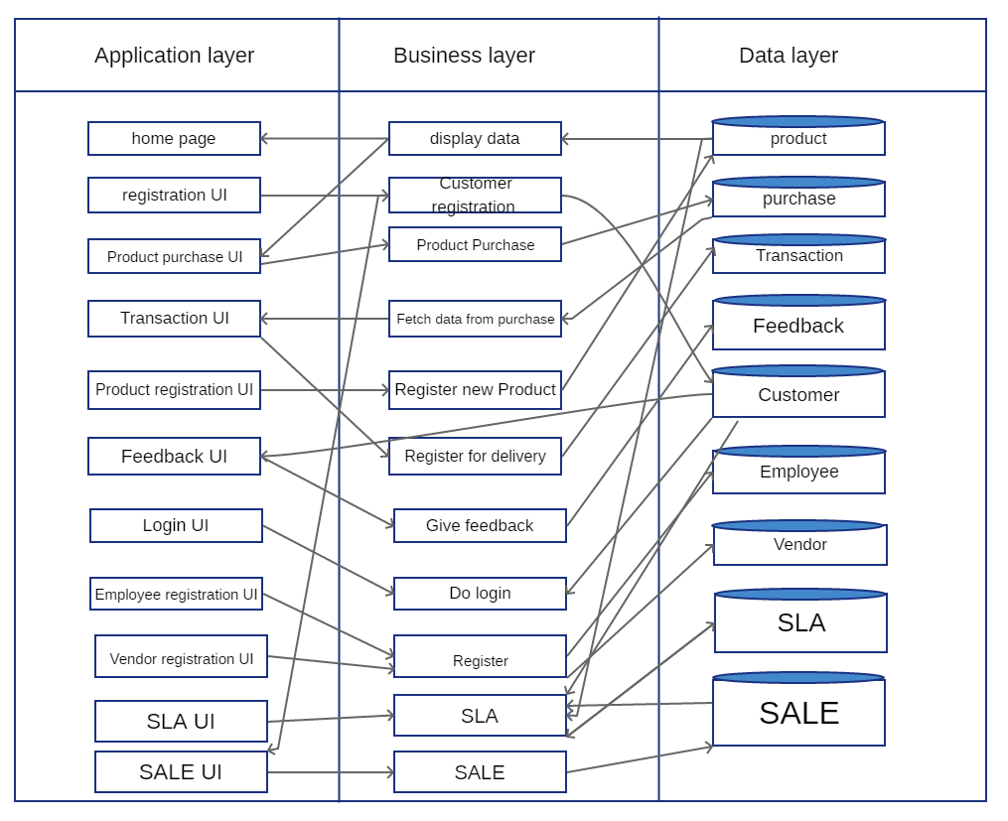

2.8 database diagram:

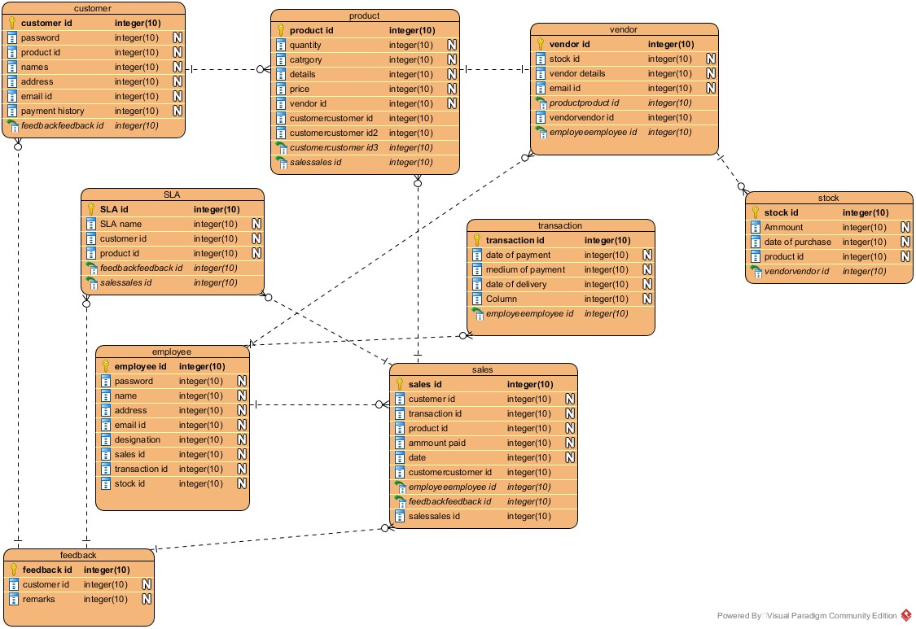

2.9 assumptions and dependencies:

- The details which are related to the product, customer, payment and services transaction are provided manually.

- Administrator is already created in the system.

- The tasks and roles are prepared.

3.3 mock up:

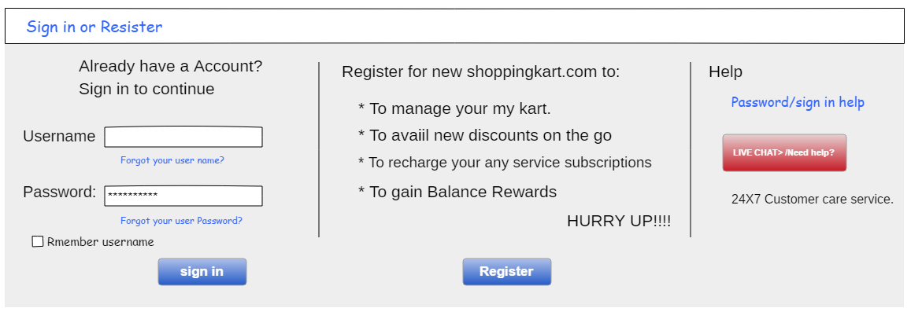
Sign-in and registration page:

Registration page:

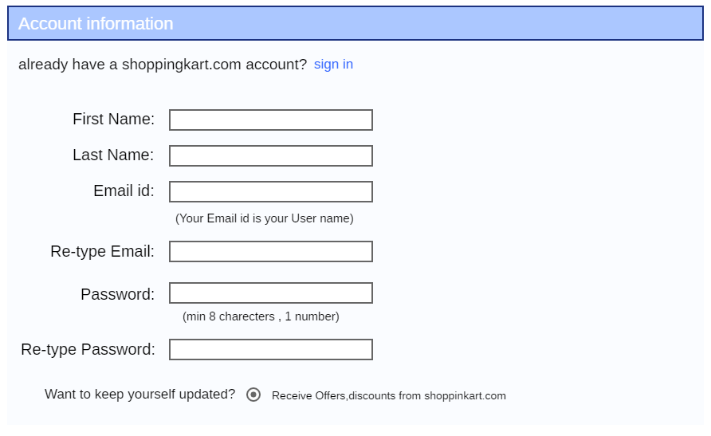
Business process and rule design:
Business process and rule design to be determined.

Conclusion:

This website will let visitors and customers browse the content and the products in the website and buy the desirable products simply via net banking and by cash as well. Allow the user to buy and store products in ‘my kart’ and give administrators the accessibility to stock products which have less no of products and resolve the problems of the customers by giving customer care service.

